
KWARA STATE UNIVERSITY, MALETE
The Green University for Community Development and Entrepreneurship

Faculty of Information and Communication Technology

CLASSIFICATION OF ELECTROCARDIOGRAM (ECG) SIGNALS USING KOHONEN SELF ORGANIZING MAP NEURAL NETWORK
BY
OREBANJO AYOMIDE SOLOMON
19/7CS/00159

SEPTEMBER, 2023


CLASSIFICATION OF ELECTROCARDIOGRAM (ECG) SIGNALS USING KOHONEN SELF ORGANIZING MAP NEURAL NETWORK
BY
OREBANJO AYOMIDE SOLOMON
19/7CS/00159

A RESEARCH PROJECT SUBMITTED TO THE DEPARTMENT OF COMPUTER SCIENCE, FACULTY OF INFORMATION AND COMMUNICATION, KWARA STATE UNIVERSITY, MALETE.
IN PARTIAL FULFILLMENT OF THE REQUIREMENT FOR THE AWARD OF BACHELOR OF SCIENCE DEGREE IN COMPUTER SCIENCE.

SEPTEMBER, 2023

DECLARATION
I Orebanjo Ayomide Solomon, solemnly declare that the project entitled “Classification of Electrocardiogram (ECG) Signals using Kohonen Self Organizing Map Neural Network” presented in this document is the result of my independent work and research. I affirm that this project has not been submitted for any other degree, diploma, or academic recognition. I further declare that all the information, data, and sources used in this project have been appropriately cited and referenced. Any contributions or assistance received from individuals or organizations in the completion of this project have been duly acknowledged.

Orebanjo Ayomide Solomon ___________________
Name of Student Signature and Date

CERTIFICATION
This is to certify that this research work on “Classification of Electrocardiogram (ECG) Signals using Kohonen Self Organizing Map Neural Network” was carried out by “Orebanjo Ayomide Solomon”. The project has been read and approved as meeting the requirements for the award of Bachelor of Science (B.Sc.), Degree in Computer Science, in the Department of Computer Science, Faculty of Information and Communication Technology, Kwara State University, Malete.

Dr. (Mrs.) R.S. Babatunde -----------------------------
Project Supervisor Date and Signature

Dr. (Mrs.) R.S. Babatunde ------------------------------
Head of Department Date and Signature

----------------------- -----------------------------
External Supervisor Date and Signature

DEDICATION
This research project is dedicated to “ALMIGHTY GOD” for the enabling strength he bestowed on me in completing this work.

ACKNOWLEDGEMENT
I are most grateful to Almighty God, the sole provider of knowledge, wisdom, love, mercy, forgiveness, and help for his protection throughout the period of my undergraduate program.
I appreciate my parents for their support, prayers, love, advice and care.
I also appreciate everyone who always encouraged and motivated me to pursue my education and dream .
I sincerely appreciate my project supervisor, Dr. (Mrs.) R.S. Babatunde, who offered timely support and guidance that led me through the various stages of this project and my overall growth as a researcher.
I would like to extend my appreciation to the faculty and staff of our world-class university (KWASU) for providing a stimulating academic environment, resources, and opportunities for learning and research..
I would like to express my heartfelt gratitude to my friends in Malete (course-mates, hostel-mates, et al.), who made my stay in Malete a lively and comfortable place.
Without the support of Almighty God, then all these individuals, this project would not have been possible. Thank you for being a part of my journey and for helping me to turn my aspirations into reality.

TABLE OF CONTENT
FRONT PAGE......................................................………........................................I
TITLE PAGE.............................................................…..……….…...................................II
DECLARATION....................................................…………..................................III
CERTIFICATION............................................................…………........................IV
DEDICATION..................................................................................…………........V
ACKNOWLEDGEMENT.....................................................................…………..VI
TABLES OF CONTENTS...................................................................…………...VII
LIST OF FIGUES.................................................................................…………..VIII
LIST OF TABLES...................................................................................………….IX
ABSTRACT.................................................................................................………..X
TABLES OF CONTENTS.....................................................................………….VII
LIST OF FIGUES......................................................................................……..VIII
LIST OF TABLES..........................................................…………..........................IX
ABSTRACT.....................................................................................………..............X
CHAPTER 1: INTRODUCTION
1.1 Background of the Study
1.2 Problem Statement
1.3 Aim and Objectives
1.4 Scope of Research
1.5 Significance and Justification
1.6. Definition of Terms

CHAPTER 2: LITERATURE REVIEW
2.1 Overview of ECG Signals
2.2 Definition and Types of ECG Signals
2.3 Incidence and Mortality Rate
2.4 Existing Diagnostic and Predictive Techniques
2.5 Definition and Principle of KOHONEN or Self-Organizing Map
2.6 Advantages and Disadvantages of KOHONEN
2.7 Review of Related Works
CHAPTER 3: METHODOLOGY
3.1 System Design
3.2 Data Acquisition and Preprocessing
3.3 Model Training
3.4 Model Performance Evaluation
3.5 Result Classification
3.6 System Requirements
CHAPTER 4: RESULT AND DISCUSSION
4.1 Introduction
4.2 Implementation
4.3 System Testing and Performance Evaluation
CHAPTER 5: SUMMARY CONCLUSION & RECOMMENDATION
5.1 Conclusion
5.2 Summary
5.3 Recommendations
REFERENCES
APPENDIX
LIST OF FIGURES
Figure
3.1: Process flow of the developed system
4.1: Importing the libraries
4.2: Visualizing the dataset
4.3: Heart disease and health attributes
4.4: Converting character labels to numeric values
4.5: Training the SOM model
4.6: Printing classification reports for SOM model
4.7: Confusion Matrix Plot
4.8: SOM visualization with true labels – first colorbar
4.9: SOM visualization with true labels – main plot and second colorbar
4.10: SOM visualization with predicted labels

ABSTRACT
The project focuses on the classification of Electrocardiogram (ECG) signals using Kohonen Self-Organizing Map (SOM) neural networks. ECG signals are crucial in diagnosing cardiovascular diseases, making accurate classification a critical task. The Kohonen SOM, known for its ability to cluster high-dimensional data in a low-dimensional space, is employed for this purpose.
The project begins with the collection and preprocessing of a diverse ECG dataset, including normal and abnormal cardiac rhythms. Noise is removed to ensure high-quality input for the neural network.
A Kohonen SOM neural network (MiniSom model) is trained using the preprocessed ECG data. The SOM organizes ECG signals into clusters on a topological map, preserving similarities and dissimilarities between different cardiac rhythms. Subsequently, the trained SOM serves as a reference model for classifying unseen ECG signals, indicating the corresponding cardiac rhythm.
The project evaluates the classification system's performance using standard metrics such as accuracy, precision, recall, and F1-score. Cross-validation techniques assess the model's robustness and generalizability. Comparative analysis is conducted to measure the effectiveness and efficiency of the SOM-based approach against other common ECG signal classification techniques.
The project's outcomes aim to contribute to biomedical signal processing and healthcare. A successful SOM-based ECG signal classification system could enhance the accuracy and speed of cardiac disease diagnosis, improving patient care and reducing healthcare costs. Additionally, this research may lead to the development of real-time ECG monitoring systems with applications in telemedicine and wearable health devices

CHAPTER ONE
INTRODUCTION
1.1 Background of the Study
The term “electrocardiogram” used to describe these wave forms was first coined by Einthoven at Dutch Medical meeting of 1893. In 1901, he successfully developed a new string galvanometer with very high sensitivity, which he used in electrocardiography. The analysis and processing of ECG signals are key approaches in the diagnosis of cardiovascular diseases(Duong et al., 2023; Śmigiel et al., 2021). The main field of work in this area is classification, which is increasingly supported by machine learning-based algorithms(Śmigiel et al., 2021). In this work a deep neural network will be developed for the automatic classification of primary ECG signals
Electrocardiography (ECG) is a medical test that detects cardiac abnormalities by measuring the electrical activity generated by the heart. The heart produces tiny electrical impulses that spread through the heart muscles. These impulses can be detected using an ECG machine. An ECG machine records the electrical activity of the heart and displays these data as a trace on paper(Prashar et al., 2020). The data will then be interpreted by a medical practitioner. ECG helps identify the cause of symptoms or chest pain and detect abnormal heart rhythm or cardiac (heart) abnormalities. ECGs from healthy hearts had characteristic shapes. Any irregularity in the heart rhythm or damage to the heart muscles can change the electrical activity of the heart; thus, the shape of the ECG changes(Zhu et al., 2021). A doctor may recommend an ECG for patients who are at risk of heart disease because of a family history of heart disease, smoking, overweight, diabetes, high cholesterol, or high blood pressure.
Heart disorders that can be detected using ECG include abnormal heart rhythms, heart attacks, and an enlarged heart. ECG records the electrical properties of heartbeats and has become one of the most important tools in the diagnosis of heart diseases(Śmigiel et al., 2021). Owing to the high mortality rate of heart diseases, early detection and precise discrimination of ECG signals are essential for the treatment of patients. The early and accurate detection of ECG arrhythmia helps doctors detect various heart diseases(Saini & Gupta, 2022). Classification of ECG signals using machine learning techniques can provide substantial input to doctors to confirm the diagnosis.
Researchers have explored various deep learning architectures for ECG classification, including convolutional neural networks (CNNs), recurrent neural networks (RNNs), and their combinations like convolutional recurrent neural networks (CRNNs). CNNs are effective in capturing spatial patterns in the ECG waveform, while RNNs excel at modeling temporal dependencies. By combining these architectures in CRNNs, researchers have achieved improved accuracy in ECG classification tasks.
The main objective of this research is to create an algorithm based on networks that can automatically classify primary ECG signals. We aim to identify and categorize types of ECG abnormalities, including irregular heart rhythms, heart attacks and an enlarged heart. Our goal is to provide professionals, with an efficient tool that can aid in the early detection and accurate differentiation of ECG signals. This will ultimately lead to diagnoses and timely treatment of diseases.

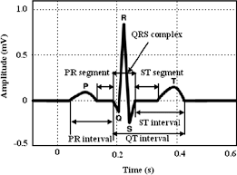

Normal ECG waveform
Kohonen Self-Organizing feature map (SOM) refers to a neural network, which is trained using competitive learning. Basic competitive learning implies that the competition process takes place before the cycle of learning. The competition process suggests that some criteria select a winning processing element. After the winning processing element is selected, its weight vector is adjusted according to the used learning law(Kohonen, 1990).
The self-organizing map makes topologically ordered mappings between input data and processing elements of the map. Topological ordered implies that if two inputs are of similar characteristics, the most active processing elements answering to inputs that are located closed to each other on the map. The weight vectors of the processing elements are organized in ascending to descending order.
It is discovered by Finnish professor and researcher Dr. Teuvo Kohonen in 1982. The self-organizing map refers to an unsupervised learning model proposed for applications in which maintaining a topology between input and output spaces. The notable attribute of this algorithm is that the input vectors that are close and similar in high dimensional space are also mapped to close by nodes in the 2D space. It is fundamentally a method for dimensionality reduction, as it maps high-dimension inputs to a low dimensional discretized representation and preserves the basic structure of its input space.

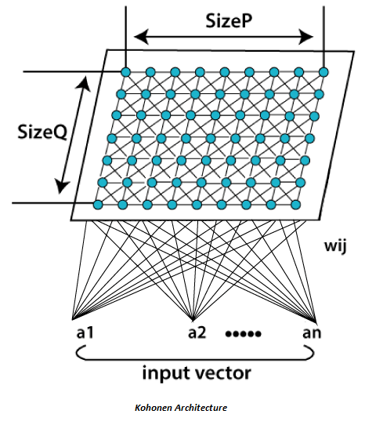

All the entire learning process occurs without supervision because the nodes are self-organizing. They are also known as feature maps, as they are basically retraining the features of the input data, and simply grouping themselves as indicated by the similarity between each other. It has practical value for visualizing complex or huge quantities of high dimensional data and showing the relationship between them into a low, usually two-dimensional field to check whether the given unlabeled data have any structure to it.
The selected node- the Best Matching Unit (BMU) is selected according to the similarity between the current input values and all the other nodes in the network. The node with the fractional Euclidean difference between the input vector, all nodes, and its neighboring nodes is selected and within a specific radius, to have their position slightly adjusted to coordinate the input vector. By experiencing all the nodes present on the grid, the whole grid eventually matches the entire input dataset with connected nodes gathered towards one area, and dissimilar ones are isolated.

1.2 Problem Statement
ECG classification problem is very important and had a strong attention from not only medical community but also community of computer scientists especially from AI field. The problem addressed in this article is sensitivity towards various quality dimensions including precision, accuracy, and timeliness. On the other hand, it is very difficult for a doctor to analyze an electrocardiogram with a long recording time for a limited time. On the other hand, people are also almost unable to recognize the morphological changes of ECG signals without tool support. Therefore, an effective computer-aided diagnosis system is needed to solve this problem to achieve better specificity, sensitivity, positive rate and accuracy.

1.3 Aim and Objectives
The aim of this project is to develop and implement a self-organizing neural network (SOM) for the classification of ECG signals. The primary objective is to accurately categorize various types of ECG abnormalities and normal patterns, providing a robust and interpretable ECG classification system. The research seeks to explore the application of SOMs in medical signal analysis, contributing to the advancement of ECG classification methods and offering healthcare professionals an effective tool for early detection and precise identification of cardiovascular diseases.
The objectives of the project are to:
- Conduct an in-depth review of self-organizing neural networks, ECG signal processing, and related literature to establish the theoretical foundation for the project.
- Gather and preprocess a comprehensive dataset of annotated ECG signals, ensuring variability in cardiac conditions and sufficient representation of abnormalities.
- Design and implement a self-organizing neural network architecture suitable for ECG classification, considering factors like network topology, learning rate, and neighborhood function.
- Evaluate and optimize the SOM model's hyper-parameters to achieve the best classification performance, ensuring high accuracy and low misclassification rates.
- Investigate the robustness of the SOM model against noisy ECG signals and variations in data acquisition processes, such as different ECG devices and sampling rates.
- Visualize the SOM's clustering and mapping of ECG signal data to provide insights into the learned representations and the organization of different cardiac patterns.
- Compare the performance of the SOM model with other traditional machine learning classifiers and deep learning-based approaches for ECG signal classification.
- Conduct a systematic analysis of the strengths and limitations of the SOM-based classification approach and propose potential areas of improvement.

1.4 Scope of Research
Kohonen self-organizing neural network is a way to reduce data dimension since it is an unsupervised learning technique to build a low-dimensional, discretized representation from the input space of the training samples. It represents a high-dimensional dataset as two-dimensional discretized pattern. And these stages will be passed while achieving the aims of this proposed project which is initialization, sampling, matching, updating, and continuation.
The SOM neural network, is used as a classifier in the process of assigning loads (represented by transforming stations) to the small area. This classification process occurs during the functioning stage of the neural network, this being done based in the transformers geographical coordinates which in turn are associated to the geographical space.
The self-organizing map is typically represented as a two-dimensional sheet of processing elements. Each processing element has its own weight vector, and learning of SOM (self-organizing map) depends on the adaptation of these vectors. The processing elements of the network are made competitive in a self-organizing process, and specific criteria pick the winning processing element whose weights are updated. Generally, these criteria are used to limit the Euclidean distance between the input vector and the weight vector. SOM (self-organizing map) varies from basic competitive learning so that instead of adjusting only the weight vector of the winning processing element also weight vectors of neighboring processing elements are adjusted. First, the size of the neighborhood is largely making the rough ordering of SOM and size is diminished as time goes on. At last, only a winning processing element is adjusted, making the fine-tuning of SOM possible. The use of neighborhood makes topologically ordering procedure possible, and together with competitive learning makes process non-linear.

1.5 Significance and Justification
This study is essential for improving how we diagnose and treat cardiovascular diseases. By developing a specialized self-organizing neural network (SOM) for ECG classification, we aim to achieve more accurate and reliable detection of various heart conditions. This means better outcomes for patients and faster intervention when needed.
One of the significant advantages of using SOMs is their ability to handle noisy ECG data, which is common in real-world situations. With our robust SOM-based model, we can effectively deal with interference and variations during data collection, making the system practical and useful in everyday clinical settings. Additionally, SOMs provide visualizations that medical practitioners can easily interpret, giving them valuable insights into how the ECG signals are classified. This interpretability allows doctors to make more informed decisions and improve their confidence in diagnosing cardiac abnormalities.
Beyond the technical benefits, the potential for real-time analysis using SOMs is a game-changer. Our fast and efficient system can aid doctors in quickly identifying heart conditions, enabling prompt and precise treatment planning for patients. This timely intervention can be critical for patients with cardiovascular issues, potentially saving lives and enhancing the overall quality of healthcare. Moreover, by exploring the application of SOMs in ECG classification, we contribute to the advancement of medical signal processing. Our research could inspire further investigations and innovations, driving progress in this vital medical field. Ultimately, we hope that our project will have a meaningful clinical impact, empowering healthcare professionals to make accurate diagnoses, leading to better patient care and improved outcomes in the fight against cardiovascular diseases.

  - Definition of Terms
- ECG: this is a line graph that shows changes in the electrical activity of the heart over time(Praveen et al., 2021).
- Cardiovascular diseases (CVG): is a general term for conditions affecting the heart or blood vessels. It’s usually associated with a build-up of fatty deposits inside the articles (atherosclerosis) and an increase of blood cots(National Health Service, 2016).
- Diagnostic: this is the process of identifying a disease, condition, or injury from signs and symptoms and distinguishing it from other possible condition(Cook & Décary, 2020).
- UCI repository arrhythmia database: is a collection of databases, domain theories and data generators of databases, domain theories, and data generators that are used by the machine learning community for the empirical analysis of machine learning
- Ventricular: Is a complex electrical phenomenon which represent a crucial stage in electrical cardiac activity.it is expressed on the surface electrocardiogram by the interval between the start of the QRS complex and the end of the T wave or U wave (QT).
- Kohonen self-organizing neural network: is a type of artificial neutral network which is also inspired by biological models of neutral systems from 1970s. it is an unlearning approach and trained its network through a competitive learning algorithm(Kohonen, 1990).
- Abnormality ECG: an abnormal ECG was defined as the presence of 1 or more of the following: bundle branch block, conduction delay, signs of right or left ventricular hypertrophy or left atrial enlargement, prolonged QTC interval, or ST-T depression exceeding 0.5 mm and/or pathological Q waves(Szlachcic et al., 2007).
- Photoplethysmography (PPG) is an uncomplicated and inexpensive optical measurement method that is often used for heart rate monitoring purposes. PPG is a non-invasive technology that uses a light source and a photodetector at the surface of skin to measure the volumetric variations of blood circulation(Ghamari, 2018).
- MIT-BIH: Massachusetts Institute of Technology created MIT-BIH Arrhythmia Database in 1980. In this database, the ECG signal is stored and transported in MITBIT format. The MIT-BIH arrhythmia database is publicly available dataset which provides standard investigation material for the detection of heart arrhythmia. Since 1980, it is used for purpose of fundamental research and medical device development on cardiac rhythm and related diseases(Khalaf & Mohammed, 2021; Ullah et al., 2021).
- Machine Learning: Machine learning is a branch of computer science that broadly aims to enable computers to “learn” without being directly programmed. It has origins in the artificial intelligence movement of the 1950s and emphasizes practical objectives and applications, particularly prediction and optimization(Bi et al., 2019).
- Transfer Learning: A machine learning technique where knowledge learned from one task or domain is applied to a different but related task or domain, often using pre-trained models(Thomas, 2018).
- Interpretability: The property of a model that allows human users, such as medical practitioners, to understand the reasoning behind the model's decisions(Vilone & Longo, 2021).
- AdaBoost algorithm: Adaptive boosting (AdaBoost) is one of the most used ensemble classifier methods, which uses weight-voting process. It was proposed by Freund and Schapire (1997). The AdaBoost algorithm is easy to implement and can increase the classification accuracy. Also, it can be used with different classifiers.
- Logistic regression analysis: is a statistical technique to evaluate the relationship between various predictor variables (either categorical or continuous) and an outcome which is binary (dichotomous). In this article, we discuss logistic regression analysis and the limitations of this technique(Ranganathan et al., 2017).
- Random Forest Classifier: is an ensemble classifier that produces multiple decision trees, using a randomly selected subset of training samples and variables(Xiao et al., 2016).
- A recurrent neural network (RNN) is a type of artificial neural network which uses sequential data or time series data(G. Chen, 2021).
- Minisom: MiniSom is a minimalistic and Numpy based implementation of the Self Organizing Maps (Vettigli, 2021).
- Artificial Neural Network: an artificial neural network is a machine learning algorithm based on the concept of a human neuron(Han et al., 2018).
- MIT-BIH Arrhythmia Database: The MIT-BIH Arrhythmia Database contains 48 half-hour excerpts of two-channel ambulatory ECG recordings, obtained from 47 subjects studied by the BIH Arrhythmia Laboratory between 1975 and 1979,(Ullah et al., 2021)
- Performance Evaluation Metrics:
- Accuracy: Accuracy measures the proportion of correctly classified instances out of the total number of instances in the dataset. It provides an overall assessment of the model's predictive accuracy (Kohavi, 1995).
- Precision: Precision calculates the proportion of true positive predictions out of the total predicted positive instances. It represents the model's ability to correctly identify positive cases while minimizing false positives (Bradley & Mangasarian, 1997)
- Recall: Recall, also known as sensitivity or true positive rate, measures the proportion of true positive predictions out of the total actual positive instances. It represents the model's ability to correctly identify all positive cases without missing any (Bradley & Mangasarian, 1997).
- F1-score: The F1-score is the harmonic mean of precision and recall. It provides a balanced measure of the model's accuracy, considering both precision and recall simultaneously. It is useful in scenarios where there is an imbalance between classes or when false positives and false negatives are equally important (Bradley & Mangasarian, 1997).
- Support: Support refers to the number of instances in each class within the dataset. It provides context to the precision, recall, and F1-score metrics by indicating the distribution and prevalence of each class (Bradley & Mangasarian, 1997).

CHAPTER TWO
LITERATURE REVIEW
2.1 Overview of ECG Signals
ECG signals using a Kohonen Self-Organizing Neural Network (SOM). The ECG is a widely used diagnostic tool for assessing the electrical activity of the heart, and accurate classification of ECG signals can assist in the early detection and diagnosis of various heart-related conditions, including arrhythmias and heart diseases(Saini & Gupta, 2022; Zhu et al., 2021).

2.2 Definition and Types of ECG Signals
An ECG is used to see how the heart is functioning. It mainly records how often the heart beats (heart rate) and how regularly it beats (heart rhythm). It can give us important information, for instance about possible narrowing of the coronary arteries, a heart attack or an irregular heartbeat like atrial fibrillation.
There are different types of ECGs, each with its own purpose. The most common one is the "resting ECG," which you get while just relaxing, lying down, or sitting. It's like a baseline check-up for your heart health.
Another type is the "exercise stress test," where they make you walk on a treadmill or pedal a stationary bike while continuously recording your heart's activity. It's like seeing how your heart handles a workout, giving doctors valuable insights into how it responds to physical stress.
Then, there are these cool gadgets called "Holter monitors" and "event monitors." They are like little buddies you carry around with you, and they continuously record your heart activity for 24 to 48 hours (or even longer). It helps capture any sneaky irregularities that might pop up during your daily life.
One type of ECG, known as the "12-lead ECG," is like a more detailed portrait of your heart's electrical activity. By placing electrodes in different positions on your chest and limbs, it gives doctors a comprehensive view of your heart from various angles. It's like the heart's photoshoot!
Overall, ECGs are not only essential for diagnosing heart conditions but also for monitoring your heart's health over time. It's like a helpful detective, always on the lookout for any clues about your heart's well-being.

2.3 Incidence and Mortality Rate
When it comes to classifying ECG signals, there are several factors that can influence how accurate and effective the classification models are. These factors affect the patterns we see in the ECG signals and can make it tricky to distinguish between different heart conditions. Let's take a closer look at some of these factors:
- Age: The age of the patient matters because ECG signals can change as we get older. Some heart conditions might be more common in older adults, and that can affect the way their ECG looks.
- Gender: Men and women might have different ECG patterns due to differences in their hearts' structures and how they work. Some heart conditions might also be more prevalent in one gender over the other.
- Heart Rate Variability (HRV): Variations in the time between heartbeats, known as HRV, can impact the ECG classification. Unusual HRV might indicate underlying heart issues.
- Cardiovascular Disease History: People with a history of heart problems or prior heart events might have ECG signals that look different from those without such a history.
- Medications and Treatments: Certain medicines or medical treatments can affect the ECG signals, causing them to show atypical patterns.
- Other Health Conditions: People with multiple health problems might have ECG signals that reflect the influence of these other conditions on their hearts.
- Proper Electrode Placement: Making sure the ECG electrodes are placed correctly and stay in the right spot during recording is important, as movement or incorrect placement can add noise and artifacts to the signals.
- Quality of Recording Devices: The quality of the ECG recording devices can vary, and that can affect how clear and accurate the signals are.
- Noise and Artifacts: ECG signals can be affected by external noise or movement during recording, which can make them harder to interpret accurately.
- Imbalanced Data: If the dataset used for training the classification model has an uneven distribution of heart conditions, it might lead to biased results.
- Features and Model Choice: Deciding which features to extract from the ECG signals and which classification model to use can have a big impact on how well the model performs.
- Interpreting Model Outputs: Understanding and explaining why a classification model makes certain decisions is important, especially in medical settings where trust is crucial.
To address these factors, researchers and experts need to be careful about how they preprocess the data and engineer the features. They should also choose models that work well with the specific challenges of ECG signal classification. It's also important to have diverse and representative datasets to ensure the models can handle different populations. By validating the models on external datasets, we can make sure they work well in real-life situations.

2.4 Existing Diagnostic and Predictive Techniques
Understanding the heart's health through ECG signals involves a range of important techniques utilized by doctors and researchers. These techniques aid in diagnosing heart conditions, predicting potential heart problems, and monitoring patients' heart health over time. One crucial aspect is arrhythmia detection, which combines traditional ECG analysis with advanced machine learning and deep learning algorithms. Doctors rely on methods like support vector machines and artificial neural networks to accurately classify different arrhythmias, facilitating precise diagnoses.
Another significant area is ischemia detection, where computer-aided diagnostic systems with machine learning models analyze ST-segment and T-wave changes on ECGs to identify reduced blood flow to the heart muscle, often caused by coronary artery disease. Predictive techniques are also essential in assessing the risk of future heart attacks. By considering a combination of ECG features, patient details, medical history, and risk factors, doctors can estimate the likelihood of a heart attack occurrence.
Heart rate variability (HRV) analysis provides valuable insights into the autonomic nervous system's functioning and helps detect cardiac autonomic dysfunction and other heart conditions. Similarly, QT interval analysis is critical in drug safety studies and evaluating drug-induced arrhythmias. ST-segment analysis assists in detecting acute coronary syndromes and guiding clinical decisions, as ST-segment elevation or depression can indicate myocardial ischemia or infarction.
Continuous ECG monitoring systems, such as Holter monitors and event recorders, play a vital role in capturing transient arrhythmias or abnormal heart rates that might not be evident during standard resting ECGs. Furthermore, deep learning techniques, such as convolutional neural networks and recurrent neural networks, enhance the accuracy and efficiency of classifying heart conditions.
Researchers utilize feature extraction and selection techniques to transform raw ECG signals into informative representations and identify relevant features crucial for accurate classification. Additionally, ensemble methods, like bagging, boosting, and stacking, combine multiple classification models to improve the accuracy and robustness of ECG signal analysis.
These diagnostic and predictive techniques, along with the implementation of Kohonen Self-Organizing Neural Networks and other machine learning approaches, hold great promise in advancing medical practices and research. By leveraging the power of AI and machine learning, doctors can better care for their patients' hearts, enable early detection of cardiac conditions, make precise diagnoses, and implement timely interventions for improved overall heart health outcomes.

2.5 Definition and Principle of KOHONEN or Self-Organizing Map
The Kohonen Self-Organizing Neural Network, also known as the Kohonen Network or Self-Organizing Map (SOM), is an unsupervised artificial neural network used for tasks such as pattern recognition, data visualization, and clustering. It was developed by Finnish professor Teuvo Kohonen in the 1980s. The network draws inspiration from the organization and adaptive learning capabilities of the human brain(Kohonen, 1982, 1990).
The Kohonen Self-Organizing Neural Network, inspired by how our brain works, creates a simplified 2D representation of input data while maintaining their relationships. It uses a 2D grid of neurons, and each neuron is associated with a weight vector representing a point in the data space(Kohonen, 1982, 1990).
During learning, the network adjusts the weights to find the best-matching neuron for each input, creating clusters of similar data. As learning progresses, neighboring neurons get influenced by the winners, revealing meaningful patterns. This helps the network organize complex data and aids in tasks like visualizing data, finding correlations, and clustering.

2.6 Advantages and Disadvantages of KOHONEN
The Kohonen Self-Organizing Neural Network is an unsupervised learning model that excels in pattern recognition, data visualization, and clustering tasks. With its 2D grid of neurons, it can effectively visualize high-dimensional data, revealing complex data structures and patterns. The network preserves topological relationships, enabling the identification of clusters and similarities among data points. Moreover, it is computationally efficient, requiring less memory than other neural network architectures(Anikin et al., 2020).
While the Kohonen Self-Organizing Neural Network offers valuable insights, it has some limitations. It may struggle with handling highly complex and nonlinear data, making it less suitable for intricate tasks. Additio snally, manual parameter tuning is necessary for optimal performance, which can be time-consuming. Despite these challenges, the SOM remains a valuable tool for exploratory data analysis and data organization(Anikin et al., 2020).

2.7 Review of Related Works
The following is a summary of some of the related work that has been published:
- In “Robust Reconstruction of Electrocardiogram using photoplethysmography”(Tang et al., 2022), the authors proposed a robust reconstruction of electrocardiogram using photoplethysmography (PPG) with a problem addressed that PPG can be used to reconstruct the +ECG, practitioners can gain deep understanding of the patient’s cardiovascular health using the two signals. The bidirectional long short-term memory (BILSTM) model is trained and validated for 1minue to generate 3-8 min ECG signal this was the description of the methodology used with a dataset of MIMIC III database. The algorithm used to execute this project was Filter, Alignmen1, Normalization, Dataset splitting and segmentation. There was a time delay between the reconstructed ECG and the reference ECG for some records. This delay lowered the r value.
- In “A Python-Based Toolbox to Access ECG Lead Signals Quality” (Kramer et al., 2022), the authors proposed a python-Based Toolbox to Access ECG Lead Signals Quality with a problem addressed to develop an efficient algorithm able to run in near-real-time on a mobile phone. Stationary signal check, Heart rate check and Signal-to-noise ratio check were the algorithm used. The result of this approach is 94.21% of the signals were correctly categorized as acceptable or unacceptable.
- In “Imbalanced ECG signal-based heart disease classification using ensemble machine learning technique” (Rath et al., 2022), the authors proposed an Imbalanced ECG signal-based heart disease classification using ensemble machine learning technique with a problem addressed to achieve improved training and testing results under the imbalanced condition of the input data. The description of the methodology is 1,024 samples of each ECG signals are considered. The 1024-dimensional sample vectors for the ECG signals are used for training and testing of the classifiers for HD detection, MIT-BIH and PTB-ECG was the dataset used. The algorithm used to carry out this project is AdaBoost algorithm, Logistic regression, Support vector machine, LR-AdaBoost ensemble model. The proposed method result, reveals that the AdaBoost perform better than the SVM, LR-based classification models, the ensemble model yielding accuracy, F1-score, and AUC values of 0,946, 0.949 and 0.951 for the PTB-ECG dataset and 0.921,0.926 and 0.950 for the MIT-BIH dataset.
- In “A Study on Arrhythmia via ECG Signal Classification Using the Convolutional Neutral Network” (M. Wu et al., 2021), the authors proposed a Study on Arrhythmia via ECG Signal Classification Using the Convolutional Neutral Network with a problem addressed the method of identifying ECG characteristic based on machine learning. The proposed CNN network uses the average -pooling layer instead of the max-pooling layer of the compared CNN network this was the description of the methodology used in this approach, and also are the dataset used, MIT-BIH database, SVM classifier, deep genetic ensemble. The algorithm used to complete this approach is Convolutional layer, pooling layer, Fully-connected layer, dropout layer and training algorithm. This approach has a very satisfying result, the model has a better performance in accuracy, sensitivity, robustness, and anti-noise capability, its accuracy classification effectively saves medical resources which has a positive effect on clinical practice.
- In “Deep learning-based system to predict cardiac arrhythmia using hybrid features of transform techniques” (Sahoo et al., 2022) the authors proposed a study Deep learning-based system to predict cardiac arrhythmia using hybrid features of transform techniques with a problem addressed that manual screening of the electrocardiogram (ECG) signals are time consuming, strenuous, and liable to human errors. ECG analysis to denoise, detection of peaks, features extraction and classification are the description of the methodology used in this approach, also DWT and EMD are the dataset used. The algorithm used in this approach is as follows: Feature selection, Hybrid features, features selection, ECG database, ECG signal analysis and Classification. The result is best in sensitivity, specificity, accuracy of 99.22%, 99.74%, and 99.53%, respectively using DNN classifier
- In “Classification of ECG signals using multi-cumulants based evolutionary hybrid classifier” (Dalal & Vishwakarma, 2021) the author proposed this approach with a problem addressed that higher time complexity due to iterative nature of algorithms, requirement of more analysis for specific features and unbalanced databases. The methodology used in this approach is the use of pre-processing and features extraction are used before the classification. The dataset used are MLII, UCI Repository arrhythmia and PTBDB database. The algorithm responsible for the succussion of this approach are the Resampling techniques, Wavelet transform, Cumulants, Kernel extreme learning machine and Optimization algorithm. 100% accurate results for complete ECG signals of MLII and UCI repository arrhythmia database in which data is parameters obtained from ECG signals, PTBDB database are also very good with maximum percentage accuracy achieved are 99.24% (with IRST) and 99.57%.
- In “Noise reduction in ECG signals Using fully convolutional Denoising Autoencoders” (Chiang et al., 2019), the authors proposed this approach with a problem addressed thus, Noise reduction and low signal distortion and the team went ahead using Denoising Autoencoder and Fully Convolutional Network as their methodology. The dataset used in this approach is MIT-BIH Arrhythmia database. The success of this approach was achieved using Fully Convolutional Network (FCN) based denoising autoencoder (DAE) algorithm. The experimental results have found that FCN outperforms DNN and CNN especially with DNN having the worst performance more specifically the QRS complexes are not well reconstructed by DNN, leading to loss of clinical information.
- In “ECG signal classification based on deep CNN and BiLSTM”(Cheng et al., 2021) the authors proposed this approach with a problem addressed a new method for automatic identification and classification of ECG developed a dense heart rhythm network that combines a 24-layer Deep Convolutional Neural Network (DCNN) and Bidirectional Long Short-Term Memory (BiLSTM) to deeply mine the hierarchical and time-sensitive features of ECG data, and the dataset used in this model are ECG data set provided by the 2017 PhysioNet / CinC Challenge, and screened 8528 pieces of data. This method has been verified on the ECG data set provided by the 2017 PhysioNet/CinC Challenge. Its accuracy is 0.893, and its F1 score is 0.891. Experiments show that the loss function that was proposed can better fit the fluctuations in ECG training and cooperate with data denoising. Can effectively improve the accuracy of ECG recognition classification.
- In “Training machine learning models with synthetic data improves the ventricular origin in outflow tract ventricular arrhythmias”(Doste et al., 2022) the authors proposed this approach with a problem addressed Electrophysiological simulations of OVTAs to train a machine learning classification model to predict the ventricular origin if the SOO of ectopic beats. The methodology used in this approach was generation of ventricular digital twins, built with patient-specific heart meshes together with cellular and tissue electrical properties, also 31 ECGs (DS-31), open-source 12-lead ECG database of 334 OTVA patients (DS-334) were the used dataset. The algorithm was Cross validation, Data argumentation, Support Vector Machine (SVM) algorithm, machine learning (ML) algorithm Ventricular digital twins. The result with the use of stimulated ECGs for training not only predicts the OTVA SOO with good accuracy, but surpasses the performance of the databases trained with real data especially when they are used with a different database.
- In “A spatio-temporal learning-based model for sleep apnea detection using single lead ECG signals” (J. Chen et al., 2022), the authors proposed this approach with a problem addressed to develop an automated (or end-to-end) spatio-temporal learning-based SA detection method. The description of methodology is stated: The RR intervals and R-peak amplitudes are extracted from combining adjacent and labeled segments. Then the RR intervals and R-peaks amplitudes are fed into the proposed CNN-BIGRU model. Physio Net Apnea-ECG dataset, university college Dunlin sleep Apnea database are the dataset used in this approach. CNN-BIGRU model training is the only algorithm used in this approach. CNN-BIGRU achieved an accuracy of 91.22 and 97.10% for per-minute classification and per-recording classification and accuracy on the UCDDB dataset reached 91.24%.
- In “Electrocardiogram Signal Classification in the Diagnosis of Heart Disease Based on RBF Neural Network”(Fang et al., 2022) the authors proposed this approach with a problem addressed to develop an Automatic ECG analysis technology that will help the work of relevant medical staff. The description of methodology is stated: we use the MIT-BIH ECG database to extract the QRS features of ECG signals by using the Pan-Tompkins algorithm. After extraction of the samples, K -means clustering is used to screen the samples, and then, RBF neural network is used to analyze the ECG information. According to the comprehensive test results, the detection accuracy of normal ECG signals can reach 99.74%, the detection of abnormal ECG signals can reach 97.53%, and the comprehensive accuracy rate can reach 98.98%.
- In “Feature Extraction and Recognition of Human Physiological Signals Based on the Convolutional Neural Network”(Hurr et al., 2022) the authors proposed this approach with a problem addressed to develop a convolutional neural network-based extraction technique for human physiological signal features and uses an MPL classifier to detect whether the ECG signal is normal or not, taking the ECG signal as an example. The description of methodology is stated: the signal preprocessing method based on wavelet transform and morphological filtering is adopted, and the high-frequency signal is removed by wavelet transform, and the low-frequency signal is removed by morphological filtering. The result concludes that the method has good detection performance with sensitivity Sen = 99.54%, positive prediction rate PPR = 99.65%, detecting mistake ratio DER = 0.35% and precision Accuracy = 99.55%..
- In “Deep Learning-Based Data Augmentation and Model Fusion for Automatic Arrhythmia Identification and Classification Algorithms”(S. Ma et al., 2022) This study proposes a deep learning algorithm for automated ECG-based arrhythmia detection, addressing the lack of labeled ECG data and low classification accuracy. The algorithm uses generative adversarial networks to augment sparse data, and a spatial and temporal information fusion model based on ResNet and BiLSTM are used to identify different types of arrhythmias in long-term ECG. An attention mechanism is introduced to enhance key information for final classification. The proposed technique improves arrhythmia diagnostic accuracy by 99.4%, demonstrating high recognition performance and clinical value.
- In “Automated Classification of Atrial Fibrillation Using Artificial Neural Network for Wearable Devices”(F. Ma et al., 2020) the authors build a system with lower computational cost and an excellent classification performance to detect AF in real time. The model in this study is a feed-forward neural network. The model was trained and tested on the AF Termination Challenge Database and MIT-BIH Arrhythmia Database, achieving the highest sensitivity of 99.3%, specificity of 97.4%, and accuracy of 98.3%.
- In “Real-Time Arrhythmia Classification Algorithm Using Time-Domain ECG Feature Based on FFNN and CNN”(Cai et al., 2021) the authors proposed this approach focusing on low latency, practicality, and reliability. The algorithm detects QRS complex position in real-time for heartbeat segmentation and constructs an ECG_RRR feature based on the segmentation result. The algorithm is easy to deploy, as the input is the original ECG signal, and the latency is only the duration of one heartbeat cycle. The algorithm is trained using the MIT-BIH arrhythmia database and has a high recall rate, precision rate, and overall accuracy of 98.0%, 99.5%, and 97.6%, respectively.
- In “A Deep Neural Network Ensemble Classifier with Focal Loss for Automatic Arrhythmia Classification”(H. Wu et al., 2022) the authors proposed this approach to develop an automated arrhythmia classification algorithm for single-lead heartbeats, addressing the challenges of poor classification in interpatient assessment. The algorithm uses a new heartbeat segmentation method, a combination of traditional sampling and focal loss, and a deep convolutional neural network ensemble classifier for classification validation. The results show an overall accuracy of 91.89%, sensitivity of 85.37%, positive productivity of 59.51%, and specificity of 93.15%.
- In “Detection of arrhythmia in 12-lead varied-length ECG using multi-branch signal fusion network”(Dong et al., 2022) the study proposes a multi-branch signal fusion network (MBSF-Net) for automatic detection of arrhythmia in 12-lead varied-length ECG. The model uses Inception with depthwise separable convolution, spatial pyramid pooling (SPP) Layer, and multi-scale fusion Resnet to extract features from each lead of 12-lead ECG recordings. The model achieves an overall classification F1 score of 83.8% in the 12-lead ECG data of CPSC-2018, outperforming the latest ECG classification algorithms. The model retains the integrity of original signals and eliminates cropping/padding signal when dealing with varied-length signal databases.
- In “Multi-class Arrhythmia detection from 12-lead varied-length ECG using Attention-based Time-Incremental Convolutional Neural Network”(Yao et al., 2020) The study proposes ATI-CNN, a deep neural network model that combines CNN, recurrent cells, and attention module to achieve spatial and temporal fusion of information from ECG signals. This model offers flexible input length, halved parameter amount, and over 90% computation reduction in real-time processing. It achieved an overall classification accuracy of 81.2%, with accuracy increases of 7.7% and up to 26.8% in detecting paroxysmal arrhythmias.
- In “Automated arrhythmia detection using novel hexadecimal local pattern and multilevel wavelet transform with ECG signals”(Tuncer et al., 2019) This study uses discrete wavelet transform (DWT) and a novel 1-dimensional hexadecimal local pattern (1D-HLP) technique to automate arrhythmia detection using ECG signals. The ECG signals are decomposed into five levels, and 512 dimensional features are extracted from each level. These features are then concatenated, reduced using neighborhood component analysis (NCA), and then classified using a nearest neighborhood (1NN) classifier. The method achieved a classification accuracy of 95.0% in classifying 17 arrhythmia classes using the MIT-BIH Arrhythmia ECG dataset, outperforming other classical ensemble learning and deep learning methods.
In “Cross-wavelet assisted convolution neural network (AlexNet) approach for phonocardiogram signals classification”(Dhar et al., 2021) The authors have developed a method to analyze Phonocardiogram (PCG) signals to determine if a patient's heart is functioning normally or if special intervention is needed. They use a Cross-wavelet transform (XWT) assisted Convolution neural network (CNN) with the AlexNet model to detect abnormal heart sounds, which are symbols of cardiovascular disease. The method is applied to both raw and de-noised PCG data, achieving an accuracy of 98% and 97.89% when processed.

CHAPTER THREE
METHODOLOGY
3.1 System Design
Figure 3.1 below depicts the algorithm procedure/process flow for this research. As clearly shown, the system design initiates with data acquisition and ends with model comparison with built models.

Data Acquisition from data.world
Model Performance Evaluation
Model Testing With MIniSom
Model Training With MiniSom
Data Preprocessing
Model Visualization

Figure 3.1: Process flow of the developed system.

3.2 Data Acquisition and Preprocessing
The first step in the methodology involved identifying a suitable dataset for ECG signals. Data.world being a popular database platform provides a diverse range of datasets, including those related to medical research. After thorough consideration and evaluation, a dataset from data.world was selected for this project. The dataset contains a comprehensive collection of clinical records that are related to ECG signals. The dataset was acquired from data.world with the link https://data.world/informatics-edu/heart-disease-prediction. The dataset contains 270 rows and 14 columns.
The acquired dataset underwent several preprocessing steps to ensure its quality and suitability for the subsequent analysis. The following key preprocessing techniques were employed:
- Importing the libraries: Librariessuch as numpy, pandas, matplotlib and seaborn, minisom, tensorflow, e.t.c were imported. Importing libraries is an essential step in any data analysis or machine learning project, they allow access to the functionality needed for tasks like data manipulation, visualization, modeling, and more.
- Loading the dataset: The dataset was imported. Dataset importaion sets the foundation for the project work and allows for exploring, analyzing, and modelling the data effectively.
- Taking care of missing data: The dataset was carefully examined to identify and handle missing values, duplicate entries, and any other errors or inconsistencies. Missing values were either imputed using appropriate techniques or removed, depending on the extent and nature of the missing data. Duplicate entries were eliminated to avoid biases in the analysis process. By performing these cleaning procedures, the dataset's integrity and reliability were improved.
- Label encoding: Label encoding was performed to convert categorical labels or text-based data into numerical values.
- Feature Normalization: Feature normalization was performed to ensures that the features in your dataset are on a consistent scale, making your data more suitable for various machine learning algorithms and analyses.

3.3 Model Training
A Self-Organizing Map (SOM), also known as a Kohonen map, is a type of artificial neural network that is used for unsupervised learning and dimensionality reduction. The basic idea behind a Self-Organizing Map is to create a low-dimensional representation of high-dimensional data while preserving the topological relationships between data points.. There are varieties of Python libraries and implementations of self organizing map such as MiniSom, SOMPY, SOM-Toolbox, Neurolab e.t.c. MiniSom was implemented in this project.

MiniSom: MiniSom, a lightweight Python library for creating and training Self-Organizing Maps (SOMs), is a relatively simple and minimalistic implementation of SOMs. While it doesn't offer a wide range of advanced techniques and features like some other libraries, it does provide the core functionality for creating basic SOMs. MiniSom contains several techniques and features, these are:
- SOM Initialization: MiniSom allows you to initialize the SOM's grid of neurons using random values or a custom initialization scheme.
- Training: You can train the SOM using your dataset. The training process involves finding the best-matching unit (BMU) for each input data point and updating the weights of the BMU and its neighbors.
- Learning Rate and Neighborhood Radius: MiniSom supports the gradual reduction of the learning rate and the neighborhood radius over time, which is a common technique in SOM training to allow convergence.
- Customizable Grid: You can define the grid's dimensions, such as the number of rows and columns, to control the structure of the SOM.
- Distance Metrics: MiniSom allows you to choose from various distance metrics, such as Euclidean distance or cosine similarity, to determine the similarity between input data and neurons.
- Visualization: It provides basic visualization tools to visualize the trained SOM, such as the U-matrix, which shows the distances between neurons, and the component planes, which display the weight vectors of neurons.
- Saving and Loading: You can save the trained SOM and load it later for further analysis or visualization.
- Quantization: After training, you can use the SOM to quantize your input data, mapping data points to the nearest neurons on the map.

The preprocessed dataset was used to train the MiniSom model. During the training process, the hyperparameters of the model, such as the sigma and learning rate, were carefully tuned manually to optimize performance. The model was trained on the training set (together with the absence and presence data), which consisted of a portion of the preprocessed data, and aimed to learn the patterns and relationships within the data that can aid in the classification of ECG signals.

3.4 Model Performance Evaluation
After training the model, it was evaluated using the testing set, which comprised the remaining portion of the preprocessed data that was not used during training (the test dataset). The evaluation involved classifying ECG signals status of the samples in the test set and comparing the classification reports with the target. The following classification metrics were calculated:

- Accuracy: The proportion of correctly classified samples out of the total number of samples in the test set. It provides an overall measure of the model's performance.
Mathematically:

Accuracy = True Positive + True Negative

True Positive + True Negative + False Positive + False Negative

- Precision: The ratio of true positive predictions to the total number of positive predictions. It measures the model's ability to correctly identify positive cases.
Mathematically:

Precision = True Positive
True Positive + False Positive

- Recall: The ratio of true positive predictions to the total number of actual positive cases in the dataset. It measures the model's ability to correctly capture positive cases.
Mathematically:

Recall = True Positive
True Positive + False Negative

- F1 score: The harmonic mean of precision and recall. It provides a balanced measure of the model's performance by considering both precision and recall.

3.5 Result Classification
In this section, I present the results of the classification task performed on the ECG signals. The result was classified in binary form Class 0 and Class 1. Class 0 implies the absence of heart disease while Class 1 implies the presence of heart disease.

3.6 System Requirements
The software requirements for the development and deployment of the classification of ECG signals are crucial to ensure the smooth operation and optimal performance of the system. The following software components are required:
- Programming Language: The system will be implemented using Python, a versatile programming language widely used for data analysis and machine learning.
- Machine Learning Libraries: To leverage the MiniSom implementation, the Scikit-learn and the minisom among several other libraries will be utilized. Scikit-learn provides a comprehensive set of machine learning algorithms and tools for data preprocessing, model training, and evaluation.
- Integrated Development Environment (IDE): Google Colab Notebook will be used as the integrated development environment for development and experimentation. Google Colab Notebook offers an interactive notebook interface that provides efficient code execution and result visualization.
- Dataset: The dataset for the project will be downloaded in CSV format, which will be compatible with the Pandas library used for data preprocessing and analysis.

CHAPTER FOUR

RESULT AND DISCUSSION
4.1 Introduction
The results obtained after the development of the system are explained in this chapter.

4.2 Implementation
Figures 4.1 below identifies the list of libraries used during the implementation of the classification of ECG signals for the dataset.
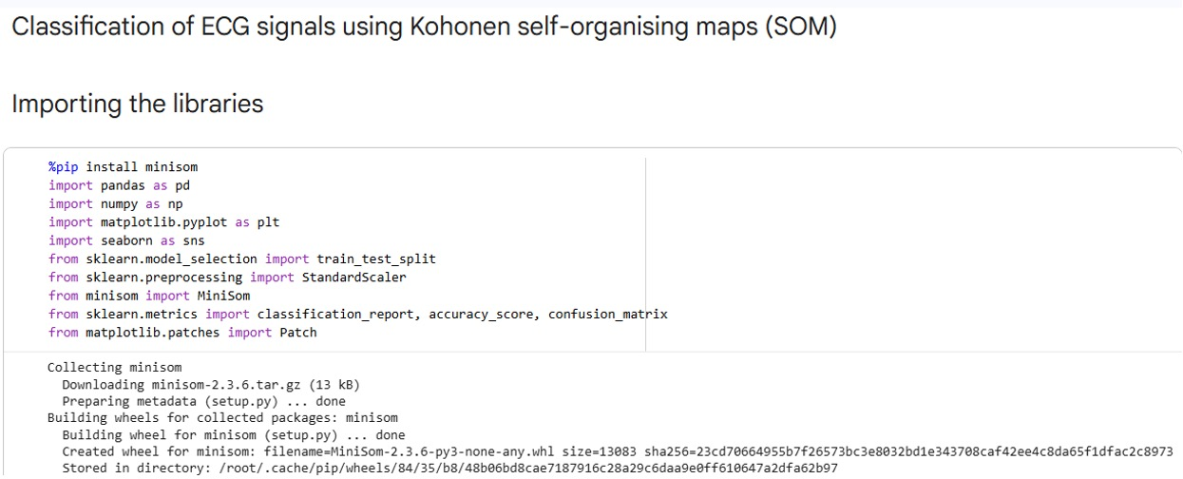

Figure 4.1: Importing the libraries.

As shown in figures 4.1 above, the libraries include pandas, NumPy, minisom, matplotlib, seaborn, among others. Pandas enable manipulation on the acquired dataset. NumPy allows representation of data in the form of array. Minisom enables creating and training Self-Organizing Maps. Matplotlib is a library used for data visualization. Seaborn, unlike matplotlib, acquires statistical data visualization.

Library importation is a crucial aspect of any programming project, including the classification of ECG signals using MiniSom model. The choice and importation of libraries plays a significant role in leveraging existing tools, algorithms, and functionalities to streamline the development process and enhance the system's capabilities.

Selection of Libraries: The selection of libraries is typically based on the requirements of the project and the specific tasks at hand. When making classification of ECG signals, several libraries can be beneficial, such as:
- Scikit-learn: A widely used machine learning library that provides various algorithms, tools, and utilities for data preprocessing, model training, and evaluation.
- MiniSom: MiniSom is a minimalistic Python library for creating and training Self-Organizing Maps. It's lightweight, easy to use, and suitable for small to medium-sized datasets.
- Pandas: A powerful library for data manipulation and analysis, providing efficient data structures and functionalities for handling datasets.
- NumPy: A fundamental library for numerical computing, offering high-performance arrays and mathematical functions that support efficient processing and computation.
- Matplotlib or Seaborn: Visualization libraries that enable the creation of informative plots and graphs to analyze and present the results.

Figure 4.2 below displays the first five rows of the imported dataset with the usage of a method called head().
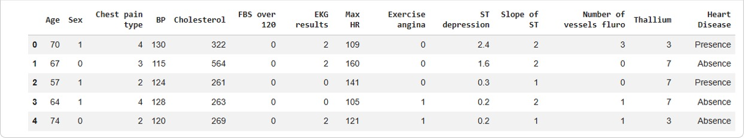
Figure 4.2: Visualizing the dataset.

Figure 4.2 above represents information related to heart disease, with each row representing an individual patient and various features describing their health.
The head of the DataFrame shows the first few rows of the data, including columns such as age, sex, chest pain type, blood pressure (BP), cholesterol levels, fasting blood sugar (FBS) status, EKG results, maximum heart rate (Max HR), exercise-induced angina, ST depression, slope of ST, the number of vessels fluoroscopy, thallium test results, and the presence or absence of heart disease.

Figure 4.3 below shows the heart disease and its health attributes.
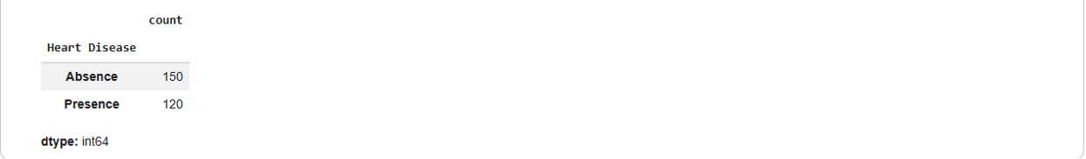

Figure 4.3: Heart disease and health attributes.

The dataset is prepared for a medical or clinical analysis task, for predicting the presence or absence of heart disease in patients based on their health attributes.

The result shows the categorical column labeled "Heart Disease" with 270 entries. Each entry represents the presence or absence of heart disease for a corresponding individual in the dataset. The following is a brief interpretation:
- "Presence": Indicates that the individual has been diagnosed with or has heart disease, with health attributes of 120 counts
- "Absence": Indicates that the individual does not have heart disease or has been diagnosed as not having heart disease with health attributes of 150 counts.

Figure 4.4 below shows how the character labels were converted to numeric values.

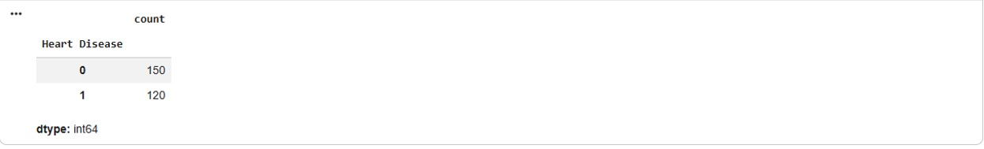
Figure 4.4: Converting character labels to numeric values.

As shown in figure 4.4 above, the result represents the conversion of character labels to numeric values. The following is a brief interpretation:
The values in `Heart Disease` column are integers, where:
- "0" typically represents one class (i.e, "Absence" or the absence of heart disease).
- "1" typically represents another class (i.e, "Presence" or the presence of heart disease).

Figure 4.5 below show how the SOM model was trained.
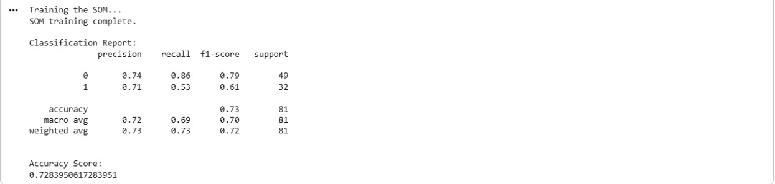

Figure 4.5: Training the SOM model.

As shown in figure 4.5 above, the messages indicate the beginning and successful completion of the Self-Organizing Map (SOM) training process. The model was initialized and then trained using the X_train_scaled data for a specified number of iterations.

4.3 System Testing and Performance Evaluation
Figure 4.6 below shows the classification report for SOM model.



Figure 4.6: Printing classification reports for SOM model.

As shown in figure 4.6 above, the classification reports summarize the performance metrics for SOM model, including precision, recall, and F1-score, averaged across folds. The following is a brief interpretation:
• Classification Report: This table shows performance metrics for each class (0 for 'Absence' of heart disease, 1 for 'Presence') and overall averages:
o Precision: For class 0, 74% of predictions as 'Absence' were correct. For class 1, 71% of predictions as 'Presence' were correct.
o Recall: For class 0, the model correctly identified 86% of all actual 'Absence' cases. For class 1, it correctly identified 53% of all actual 'Presence' cases.
o F1-score: This is a balanced measure of precision and recall. It's 0.79 for class 0 and 0.61 for class 1.
o Support: The actual number of instances for each class in the test set (49 for class 0, 32 for class 1).
• Accuracy Score: The overall accuracy of the model is approximately 72.84%, meaning it correctly classified about 73% of the samples in the test set.

Figure 4.7 below show how the Confusion Matrix heatmap was plotted.
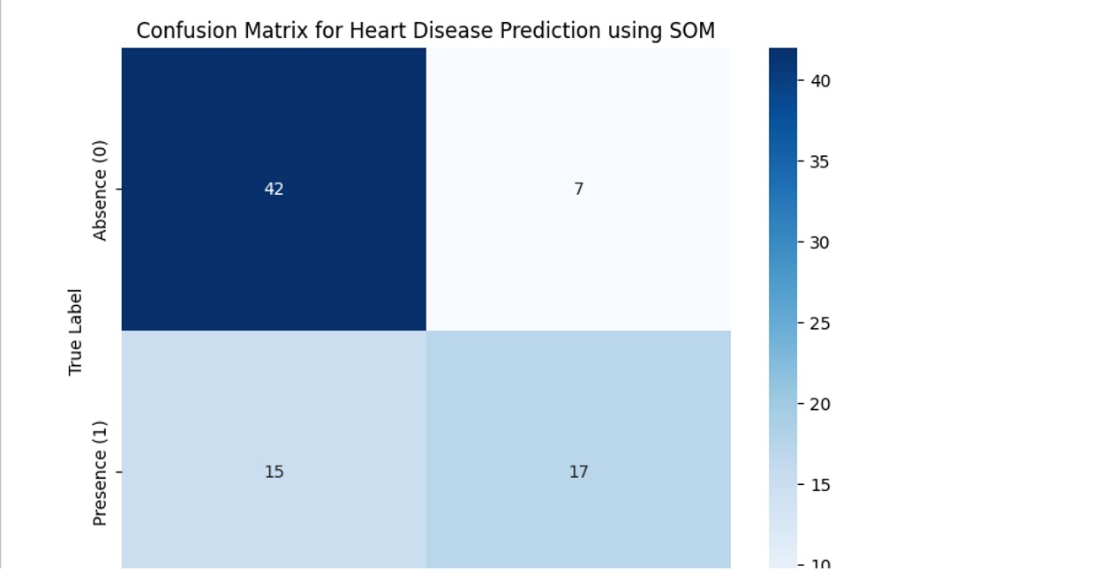
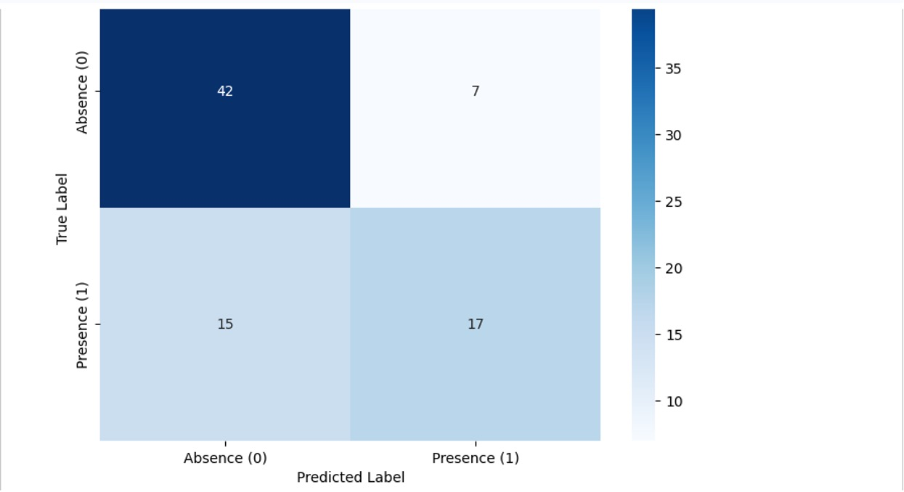

Figure 4.7: Confusion Matrix Plot.

As shown in figure 4.7 above, this cell generated a visual output: a Confusion Matrix heatmap. This plot is essential for understanding where the model made correct and incorrect predictions:
• The rows represent the True Labels (actual classes of the test samples).
• The columns represent the Predicted Labels (what your model predicted).
• The numbers in the cells indicate how many samples fall into each category:
o Top-left (42): True Negatives (Correctly predicted 'Absence' when the true label was 'Absence').
o Top-right (7): False Positives (Incorrectly predicted 'Presence' when the true label was 'Absence').
o Bottom-left (15): False Negatives (Incorrectly predicted 'Absence' when the true label was 'Presence').
o Bottom-right (17): True Positives (Correctly predicted 'Presence' when the true label was 'Presence').

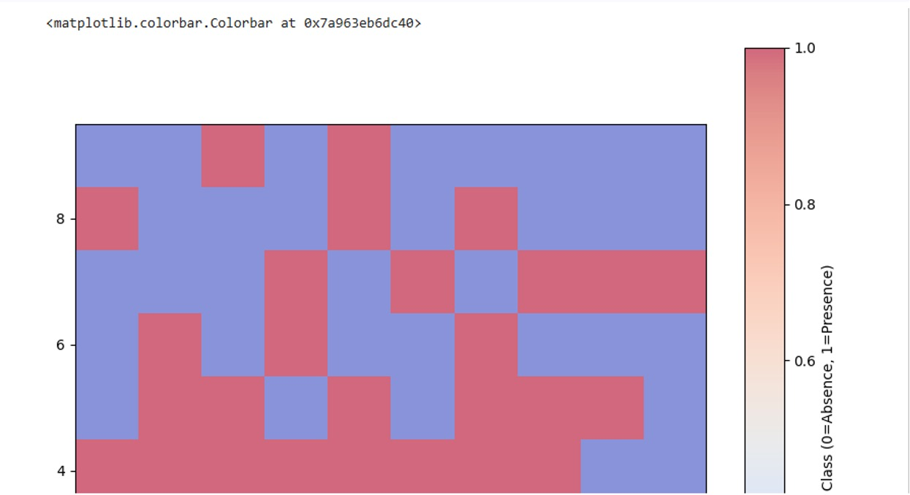
Figure 4.8 below show how the SOM model was trained.
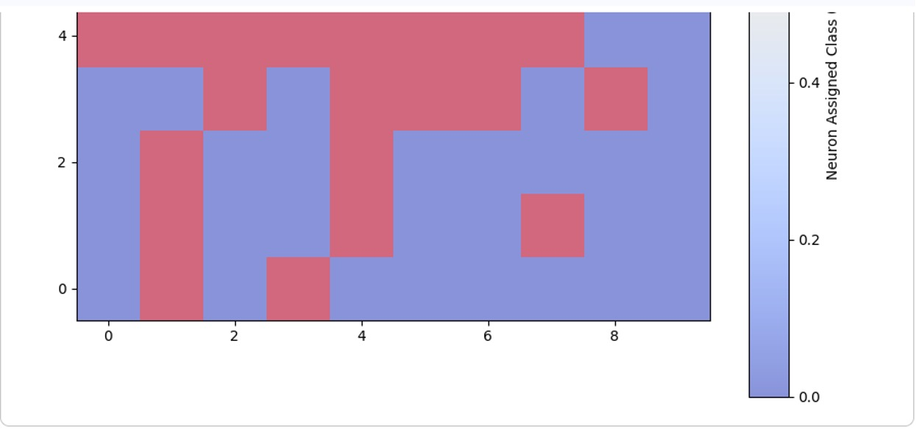
Figure 4.8: SOM visualization with true labels – first colorbar.

As shown in figure 4.8 above, the output signifies that a Matplotlib Colorbar object was created and returned. This colorbar is part of the first SOM visualization, which shows the SOM grid colored by the assigned neuron labels (0 for Absence, 1 for Presence). The colorbar itself provides the mapping between the colors on the map and the numerical class labels.

Figure 4.9 below show how the SOM model was trained.
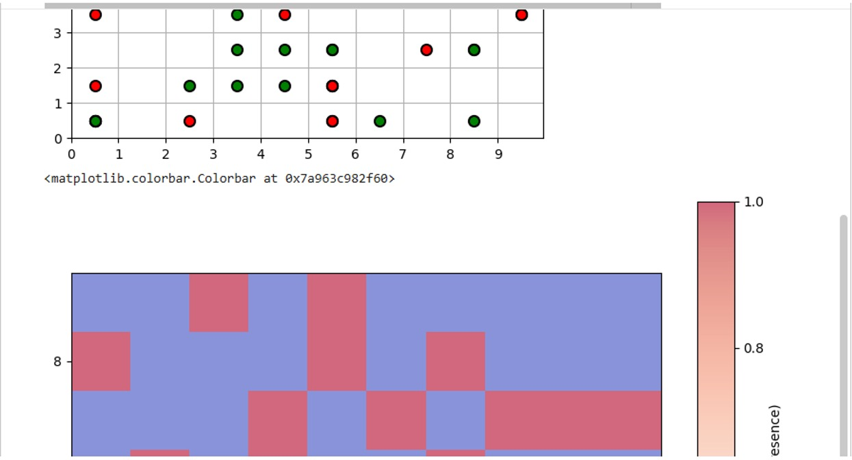
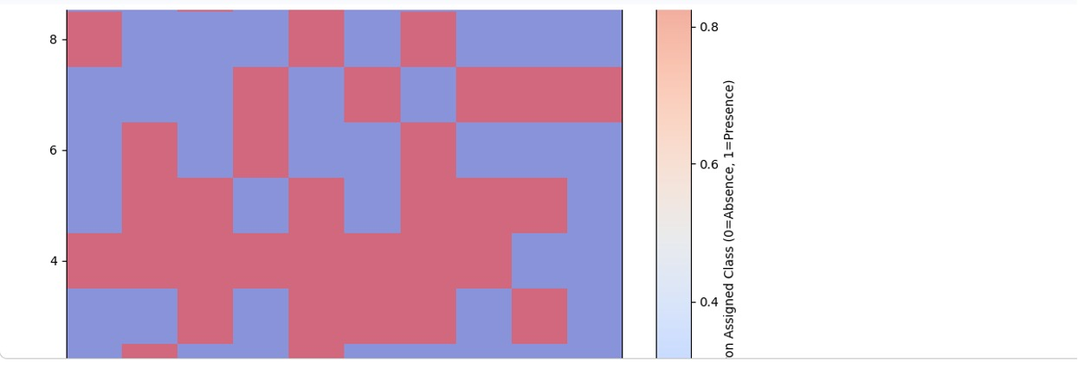
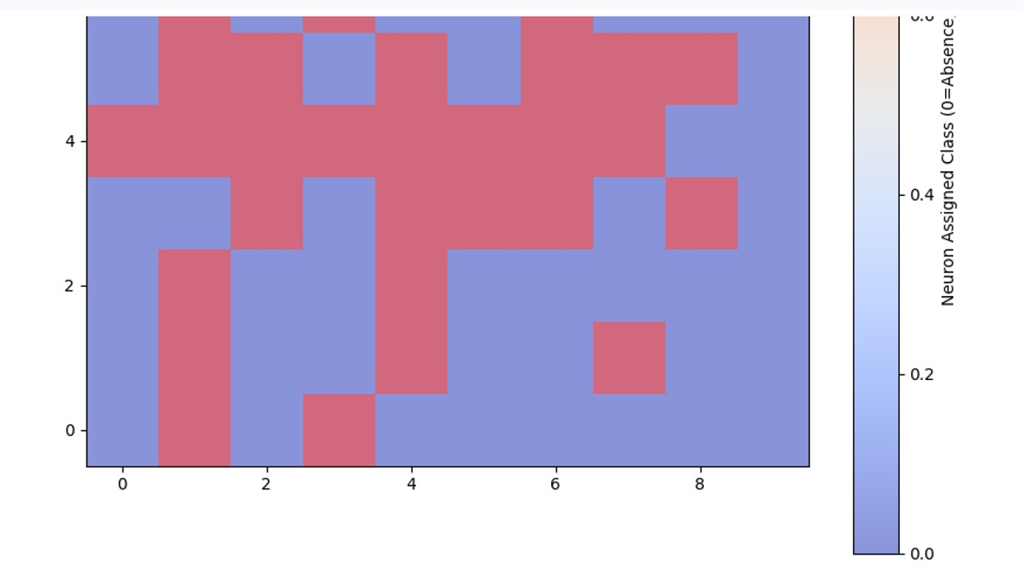

Figure 4.9 SOM visualization with true labels – main plot and second colorbar.

As shown in figure 4.9 above, similar to the previous output, this indicates the creation of another Colorbar object. This colorbar corresponds to the second imshow plot in this cell, which again displays the SOM grid with neurons colored by their assigned class. This cell generates a visualization of the SOM with test data points overlaid, colored according to their true labels (green for Absence, red for Presence). The dots are plotted on the best matching unit (BMU) for each test sample, allowing us to visually inspect how well samples of different true classes map to the SOM regions.

Figure 4.10 below show how the SOM model was trained.
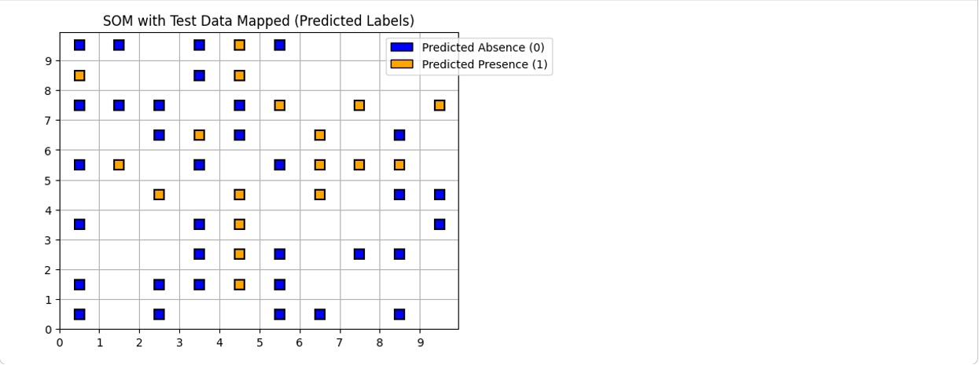

Figure 4.10: SOM visualization with predicted labels.

As shown in figure 4.10 above, the cell generated another visual output: a SOM visualization with predicted labels. This plot is similar to the previous one, but the overlaid test data points are colored according to the model's predicted labels (blue for Predicted Absence, orange for Predicted Presence). By comparing this plot with the previous one (showing true labels), we can visually assess the model's classification performance on the SOM grid. For example, if a region of the SOM is predominantly red (true Presence) but has many orange squares (predicted Absence), it indicates misclassifications in that region.

CHAPTER FIVE

SUMMARY, CONCLUSION, AND RECOMMENDATIONS
The exploration into the study has been a journey of innovation, collaboration, and potential transformation in medical diagnostics. As this project culminates, it's essential to reflect on the journey's highlights, draw meaningful conclusions, and provide recommendations for future researchers and practitioners.

5.1 Summary
The project commenced with data acquisition from the Heart Disease dataset, a cornerstone of the study's success. Through meticulous data preprocessing, the ECG signals were transformed into a standardized and informative format. The implementation phase involved configuring the Kohonen Self-Organizing Neural Network, enabling it to self-organize clusters that corresponded to different arrhythmia categories. Model performance evaluation assessed accuracy, precision, recall, and F1-score, showcasing the system's ability to accurately classify arrhythmias. The clusters' interpretation, with collaboration from medical experts, ensured clinical relevance and meaningful insights. The implementation in Google Colab showcased the potential of cloud-based environments for machine learning projects.

5.2 Conclusion
The journey's conclusion underscores the study’s success in bridging the gap between advanced machine learning techniques and medical diagnostics. The developed system, driven by the Kohonen Self-Organizing Neural Network, exhibited promising capabilities in automated arrhythmia classification. Collaboration with medical experts and validation against clinical expertise fortified the system's clinical relevance. The intersection of technology and healthcare presented a realm of possibilities for improving patient care, personalizing treatments, and enhancing medical decision-making.

5.3 Recommendations
To further enrich the impact of similar projects, several recommendations emerge:
- Diverse Dataset Usage: Expand beyond a single dataset to ensure generalization and robustness across diverse populations.
- Hyperparameter Optimization: Fine-tune model parameters for optimal performance.
- Feature Engineering Advancements: Explore advanced feature engineering techniques for more informative signal representations.
- Hybrid Models: Investigate hybrid models and ensemble methods to harness complementary strengths.
- Real-Time Implementation: Extend the system to enable real-time arrhythmia classification for immediate clinical insights.
- Continuous Collaboration: Foster ongoing collaboration with medical professionals for accuracy and relevance.
- Integration into Healthcare: Explore integration strategies into existing healthcare systems for seamless adoption.
- Class Imbalance Mitigation: Address class imbalance to enhance performance on underrepresented categories.
- Cross-Dataset Generalization: Assess model generalization across different ECG datasets for real-world applicability.
- Ethical and Regulatory Compliance: Uphold ethical and regulatory guidelines for responsible deployment.
In the nexus of technology and medicine, the study exemplifies the potential to revolutionize medical diagnostics. This journey underscores the power of collaboration, innovation, and continuous exploration in enhancing patient care, demonstrating the ever-evolving promise of artificial intelligence in healthcare.

REFERENCES
Anikin, V., Anikina, O., & Gushchina, O. (2020). Kohonen neural network training by cellular automaton. Romanian Journal of Information Science and Technology, 23(T).
Bi, Q., Goodman, K. E., Kaminsky, J., & Lessler, J. (2019). What is machine learning? A primer for the epidemiologist. American Journal of Epidemiology, 188(12). https://doi.org/10.1093/aje/kwz189
Cai, J., Zhou, G., Dong, M., Hu, X., Liu, G., & Ni, W. (2021). Real-Time Arrhythmia Classification Algorithm Using Time-Domain ECG Feature Based on FFNN and CNN. Mathematical Problems in Engineering, 2021. https://doi.org/10.1155/2021/6648432
Chen, G. (2021). Recurrent neural networks (RNNs) learn the constitutive law of viscoelasticity. Computational Mechanics, 67(3). https://doi.org/10.1007/s00466-021-01981-y
Chen, J., Shen, M., Ma, W., & Zheng, W. (2022). A spatio-temporal learning-based model for sleep apnea detection using single-lead ECG signals. Frontiers in Neuroscience, 16. https://doi.org/10.3389/fnins.2022.972581
Cheng, J., Zou, Q., & Zhao, Y. (2021). ECG signal classification based on deep CNN and BiLSTM. BMC Medical Informatics and Decision Making, 21(1). https://doi.org/10.1186/s12911-021-01736-y
Chiang, H. T., Hsieh, Y. Y., Fu, S. W., Hung, K. H., Tsao, Y., & Chien, S. Y. (2019). Noise Reduction in ECG Signals Using Fully Convolutional Denoising Autoencoders. IEEE Access, 7. https://doi.org/10.1109/ACCESS.2019.2912036
Cook, C. E., & Décary, S. (2020). Higher order thinking about differential diagnosis. In Brazilian Journal of Physical Therapy (Vol. 24, Issue 1). https://doi.org/10.1016/j.bjpt.2019.01.010
Dalal, S., & Vishwakarma, V. P. (2021). Classification of ECG signals using multi-cumulants based evolutionary hybrid classifier. Scientific Reports, 11(1). https://doi.org/10.1038/s41598-021-94363-6
Dhar, P., Dutta, S., & Mukherjee, V. (2021). Cross-wavelet assisted convolution neural network (AlexNet) approach for phonocardiogram signals classification. Biomedical Signal Processing and Control, 63. https://doi.org/10.1016/j.bspc.2020.102142
Dong, Y., Cai, W., Qiu, L., Guo, Y., Chen, Y., Zhang, M., Wang, D., Zhang, H., & Wang, L. (2022). Detection of arrhythmia in 12-lead varied-length ECG using multi-branch signal fusion network. Physiological Measurement, 43(10). https://doi.org/10.1088/1361-6579/ac7938
Doste, R., Lozano, M., Jimenez-Perez, G., Mont, L., Berruezo, A., Penela, D., Camara, O., & Sebastian, R. (2022). Training machine learning models with synthetic data improves the prediction of ventricular origin in outflow tract ventricular arrhythmias. Frontiers in Physiology, 13. https://doi.org/10.3389/fphys.2022.909372
Duong, L. T., Doan, T. T. H., Chu, C. Q., & Nguyen, P. T. (2023). Fusion of edge detection and graph neural networks to classifying electrocardiogram signals. Expert Systems with Applications, 225. https://doi.org/10.1016/j.eswa.2023.120107
Fang, Y., Shi, J., Huang, Y., Zeng, T., Ye, Y., Su, L., Zhu, D., & Huang, J. (2022). Electrocardiogram Signal Classification in the Diagnosis of Heart Disease Based on RBF Neural Network. Computational and Mathematical Methods in Medicine, 2022. https://doi.org/10.1155/2022/9251225
Ghamari, M. (2018). A review on wearable photoplethysmography sensors and their potential future applications in health care. International Journal of Biosensors & Bioelectronics, 4(4). https://doi.org/10.15406/ijbsbe.2018.04.00125
Han, S.-H., Kim, K. W., Kim, S., & Youn, Y. C. (2018). Artificial Neural Network: Understanding the Basic Concepts without Mathematics. Dementia and Neurocognitive Disorders, 17(3). https://doi.org/10.12779/dnd.2018.17.3.83
Hurr, C., Li, C., & Li, H. (2022). Feature Extraction and Recognition of Human Physiological Signals Based on the Convolutional Neural Network. Mobile Information Systems, 2022. https://doi.org/10.1155/2022/8982881
Khalaf, A. J., & Mohammed, S. J. (2021). Verification and comparison of MIT-BIH arrhythmia database based on number of beats. International Journal of Electrical and Computer Engineering, 11(6). https://doi.org/10.11591/ijece.v11i6.pp4950-4961
Kohonen, T. (1982). Self-organized formation of topologically correct feature maps. Biological Cybernetics, 43(1). https://doi.org/10.1007/BF00337288
Kohonen, T. (1990). The Self-Organizing Map. Proceedings of the IEEE, 78(9). https://doi.org/10.1109/5.58325
Kramer, L., Menon, C., & Elgendi, M. (2022). ECGAssess: A Python-Based Toolbox to Assess ECG Lead Signal Quality . In Frontiers in Digital Health (Vol. 4). https://www.frontiersin.org/articles/10.3389/fdgth.2022.847555
Ma, F., Zhang, J., Liang, W., & Xue, J. (2020). Automated Classification of Atrial Fibrillation Using Artificial Neural Network for Wearable Devices. Mathematical Problems in Engineering, 2020. https://doi.org/10.1155/2020/9159158
Ma, S., Cui, J., Xiao, W., & Liu, L. (2022). Deep Learning-Based Data Augmentation and Model Fusion for Automatic Arrhythmia Identification and Classification Algorithms. Computational Intelligence and Neuroscience, 2022. https://doi.org/10.1155/2022/1577778
National Health Service. (2016). Cardiovascular disease - NHS.UK. National Health Service.
Prashar, N., Sood, M., & Jain, S. (2020). Novel Cardiac Arrhythmia Processing using Machine Learning Techniques. International Journal of Image and Graphics, 20(3). https://doi.org/10.1142/S0219467820500230
Praveen, P., Samartha, B., Pai, V. R., Namith Rao, M., Shivaprakasha, K. S., & Bhandarkar, R. (2021). Generation of ECG Arrhythmias Using Fourier Analysis. Lecture Notes in Electrical Engineering, 752 LNEE. https://doi.org/10.1007/978-981-16-0443-0_29
Ranganathan, P., Pramesh, C., & Aggarwal, R. (2017). Common pitfalls in statistical analysis: Logistic regression. Perspectives in Clinical Research, 8(3). https://doi.org/10.4103/picr.PICR_87_17
Rath, A., Mishra, D., & Panda, G. (2022). Imbalanced ECG signal-based heart disease classification using ensemble machine learning technique . In Frontiers in Big Data (Vol. 5). https://www.frontiersin.org/articles/10.3389/fdata.2022.1021518
Sahoo, S., Dash, P., Mishra, B. S. P., & Sabut, S. K. (2022). Deep learning-based system to predict cardiac arrhythmia using hybrid features of transform techniques. Intelligent Systems with Applications, 16. https://doi.org/10.1016/j.iswa.2022.200127
Saini, S. K., & Gupta, R. (2022). Artificial intelligence methods for analysis of electrocardiogram signals for cardiac abnormalities: state-of-the-art and future challenges. Artificial Intelligence Review, 55(2). https://doi.org/10.1007/s10462-021-09999-7
Śmigiel, S., Pałczyński, K., & Ledziński, D. (2021). ECG signalclassification using deep learningtechniques based on the PTB-XL dataset. Entropy, 23(9). https://doi.org/10.3390/e23091121
Szlachcic, Y., Carrothers, L. A., Adkins, R., & Waters, R. (2007). Clinical significance of abnormal electrocardiographic findings in individuals aging with spinal injury and abnormal lipid profiles. Journal of Spinal Cord Medicine, 30(5). https://doi.org/10.1080/10790268.2007.11754580
Tang, Q., Chen, Z., Guo, Y., Liang, Y., Ward, R., Menon, C., & Elgendi, M. (2022). Robust Reconstruction of Electrocardiogram Using Photoplethysmography: A Subject-Based Model. Frontiers in Physiology, 13. https://doi.org/10.3389/fphys.2022.859763
Thomas, R. (2018). What is transfer learning? Fast.Ai, 1.
Tuncer, T., Dogan, S., Pławiak, P., & Rajendra Acharya, U. (2019). Automated arrhythmia detection using novel hexadecimal local pattern and multilevel wavelet transform with ECG signals. Knowledge-Based Systems, 186. https://doi.org/10.1016/j.knosys.2019.104923
Ullah, A., Rehman, S. U., Tu, S., Mehmood, R. M., Fawad, & Ehatisham-Ul-haq, M. (2021). A hybrid deep CNN model for abnormal arrhythmia detection based on cardiac ECG signal. Sensors (Switzerland), 21(3). https://doi.org/10.3390/s21030951
Vettigli, G. (2021). MiniSom, a minimalistic and Numpy based implementation of the Self Organizing Maps Giuseppe. The Journal of Open Source Software.
Vilone, G., & Longo, L. (2021). Notions of explainability and evaluation approaches for explainable artificial intelligence. Information Fusion, 76. https://doi.org/10.1016/j.inffus.2021.05.009
Wu, H., Zhang, S., Bao, B., Li, J., Zhang, Y., Qiu, D., & Yang, H. (2022). A Deep Neural Network Ensemble Classifier with Focal Loss for Automatic Arrhythmia Classification. Journal of Healthcare Engineering, 2022. https://doi.org/10.1155/2022/9370517
Wu, M., Lu, Y., Yang, W., & Wong, S. Y. (2021). A Study on Arrhythmia via ECG Signal Classification Using the Convolutional Neural Network . In Frontiers in Computational Neuroscience (Vol. 14). https://www.frontiersin.org/articles/10.3389/fncom.2020.564015
Xiao, W., Vallet, B., Schindler, K., & Paparoditis, N. (2016). ISPRS Journal of Photogrammetry and Remote Sensing Street-side vehicle detection , classification and change detection using mobile laser scanning data. ISPRS Journal of Photogrammetry and Remote Sensing, 114(C).
Yao, Q., Wang, R., Fan, X., Liu, J., & Li, Y. (2020). Multi-class Arrhythmia detection from 12-lead varied-length ECG using Attention-based Time-Incremental Convolutional Neural Network. Information Fusion, 53. https://doi.org/10.1016/j.inffus.2019.06.024
Zhu, Z., Lan, X., Zhao, T., Guo, Y., Kojodjojo, P., Xu, Z., Liu, Z., Liu, S., Wang, H., Sun, X., & Feng, M. (2021). Identification of 27 abnormalities from multi-lead ECG signals: An ensembled SE_ResNet framework with Sign Loss function. Physiological Measurement, 42(6). https://doi.org/10.1088/1361-6579/ac08e

APPENDIX
SOURCE CODE
# Classification of ECG signal using Kohonen self-organizing maps (SOM) # Importing the libraries
%pip install minisom
# Importing the libraries
import pandas as pd
import numpy as np
import matplotlib.pyplot as plt
import seaborn as sns
from sklearn.model_selection import train_test_split
from sklearn.preprocessing import StandardScaler
from minisom import MiniSom
from sklearn.metrics import classification_report, accuracy_score, confusion_matrix
from matplotlib.patches import Patch

# Loading the dataset
df = pd.read_csv('/content/ Heart_Disease_Prediction.csv')

# Displaying the first 5 rows of the DataFrame
display(df.head())

# Displaying basic information about the dataset
display(df.info())

# Checking the unique values and their counts in the 'Heart Disease' column
display(df['Heart Disease'].value_counts())

## Converting 'Heart Disease' column to numerical representation
# Assuming 'Presence' = 1 and 'Absence' = 0 based on the typical classification tasks
df['Heart Disease'] = df['Heart Disease'].map({'Presence': 1, 'Absence': 0})

# Displaying the updated value counts to confirm the conversion
display(df['Heart Disease'].value_counts())

# Displaying the first few rows with the updated 'Heart Disease' column
display(df.head())

# Separating features (X) and target (y)
X = df.drop('Heart Disease', axis=1)
y = df['Heart Disease']

# Splitting the dataset into training and testing sets
X_train, X_test, y_train, y_test = train_test_split(X, y, test_size=0.3, random_state=42)

# Standardizing the features
scaler = StandardScaler()
X_train_scaled = scaler.fit_transform(X_train)
X_test_scaled = scaler.transform(X_test)

print(f"X_train_scaled shape: {X_train_scaled.shape}")
print(f"X_test_scaled shape: {X_test_scaled.shape}")

# Defining the dimensions of the SOM grid
som_dim_x = 10
som_dim_y = 10

# Initializing the SOM
som = MiniSom(som_dim_x, som_dim_y, X_train_scaled.shape[1],
sigma=0.5, learning_rate=0.5,
neighborhood_function='gaussian', random_seed=42)

# Initializing SOM weights randomly
som.random_weights_init(X_train_scaled)

# Training the SOM
print("Training the SOM...")
som.train_random(X_train_scaled, num_iteration=1000)
print("SOM training complete.")

# Map training data to the SOM and assign labels to each neuron
winner_coordinates = np.array([som.winner(x) for x in X_train_scaled])

# Creating a dictionary to store the class counts for each neuron
neuron_labels = np.zeros((som_dim_x, som_dim_y), dtype=int)

for i in range(som_dim_x):
for j in range(som_dim_y):
# Getting all training samples that map to this neuron
mapped_samples_indices = np.where((winner_coordinates[:, 0] == i) & (winner_coordinates[:, 1] == j))[0]
if len(mapped_samples_indices) > 0:
# Getting the labels of these samples
labels_of_mapped_samples = y_train.iloc[mapped_samples_indices]

# Assign the majority class to the neuron
if not labels_of_mapped_samples.empty:
unique_labels, counts = np.unique(labels_of_mapped_samples, return_counts=True)
neuron_labels[i, j] = unique_labels[np.argmax(counts)]
else:
# If no samples map to this neuron, assign a default label
neuron_labels[i, j] = 0

# Predicting on the test set
y_pred = []
for x_test_sample in X_test_scaled:
bmu = som.winner(x_test_sample)
y_pred.append(neuron_labels[bmu[0], bmu[1]])

y_pred = np.array(y_pred)

# Evaluating the model
print("\nClassification Report:")
print(classification_report(y_test, y_pred))

print("\nAccuracy Score:")
print(accuracy_score(y_test, y_pred))

# Computing the confusion matrix
cm = confusion_matrix(y_test, y_pred)

# Plotting the confusion matrix
plt.figure(figsize=(8, 6))
sns.heatmap(cm, annot=True, fmt='d', cmap='Blues',
xticklabels=['Absence (0)', 'Presence (1)'],
yticklabels=['Absence (0)', 'Presence (1)'])
plt.xlabel('Predicted Label')
plt.ylabel('True Label')
plt.title('Confusion Matrix for Heart Disease Prediction using SOM')
plt.show()

# Getting the winning neurons for each test sample
test_winner_coordinates = np.array([som.winner(x) for x in X_test_scaled])

plt.figure(figsize=(10, 10))
# Plotting the U-matrix to show distances between neurons

# Plotting the neuron labels as the background
plt.imshow(neuron_labels.T, cmap='coolwarm', alpha=0.6, origin='lower') # Transposing for correct orientation
plt.colorbar(label='Neuron Assigned Class (0=Absence, 1=Presence)')

# Overlaying test points with their true labels
for i, (x_coord, y_coord) in enumerate(test_winner_coordinates):
color = 'green' if y_test.iloc[i] == 0 else 'red'
marker = 'o'
plt.plot(x_coord + 0.5, y_coord + 0.5, marker, markerfacecolor=color, markeredgecolor='black', markersize=8, markeredgewidth=1.5)

plt.title('SOM with Test Data Mapped (True Labels)')
plt.xticks(np.arange(som_dim_x))
plt.yticks(np.arange(som_dim_y))
plt.grid(True)

legend_elements = [
Patch(facecolor='green', edgecolor='black', label='True Absence (0)'),
Patch(facecolor='red', edgecolor='black', label='True Presence (1)')
]
plt.legend(handles=legend_elements, loc='upper right', bbox_to_anchor=(1.25, 1))
plt.show()

plt.figure(figsize=(10, 10))
# Plotting the neuron labels as the background
plt.imshow(neuron_labels.T, cmap='coolwarm', alpha=0.6, origin='lower') # Transposing for correct orientation
plt.colorbar(label='Neuron Assigned Class (0=Absence, 1=Presence)')

# Overlaying test points with their predicted labels
for i, (x_coord, y_coord) in enumerate(test_winner_coordinates):
color = 'blue' if y_pred[i] == 0 else 'orange'
marker = 's'
plt.plot(x_coord + 0.5, y_coord + 0.5, marker, markerfacecolor=color, markeredgecolor='black', markersize=8, markeredgewidth=1.5)

plt.title('SOM with Test Data Mapped (Predicted Labels)')
plt.xticks(np.arange(som_dim_x))
plt.yticks(np.arange(som_dim_y))
plt.grid(True)

legend_elements_pred = [
Patch(facecolor='blue', edgecolor='black', label='Predicted Absence (0)'),
Patch(facecolor='orange', edgecolor='black', label='Predicted Presence (1)')
]
plt.legend(handles=legend_elements_pred, loc='upper right', bbox_to_anchor=(1.25, 1))
plt.show()

https://colab.research.google.com/drive/1SaQSFUBZBZSkAouiZbXYKu_2YGLqoMdV?usp=sharing

